MIDLOTHIAN EDUCATION AND COMMUNITIES DIVISION
STANDARDS AND QUALITY REPORT

Moorfoot Primary
‘Getting it Right for Everyone’
2014 – 15
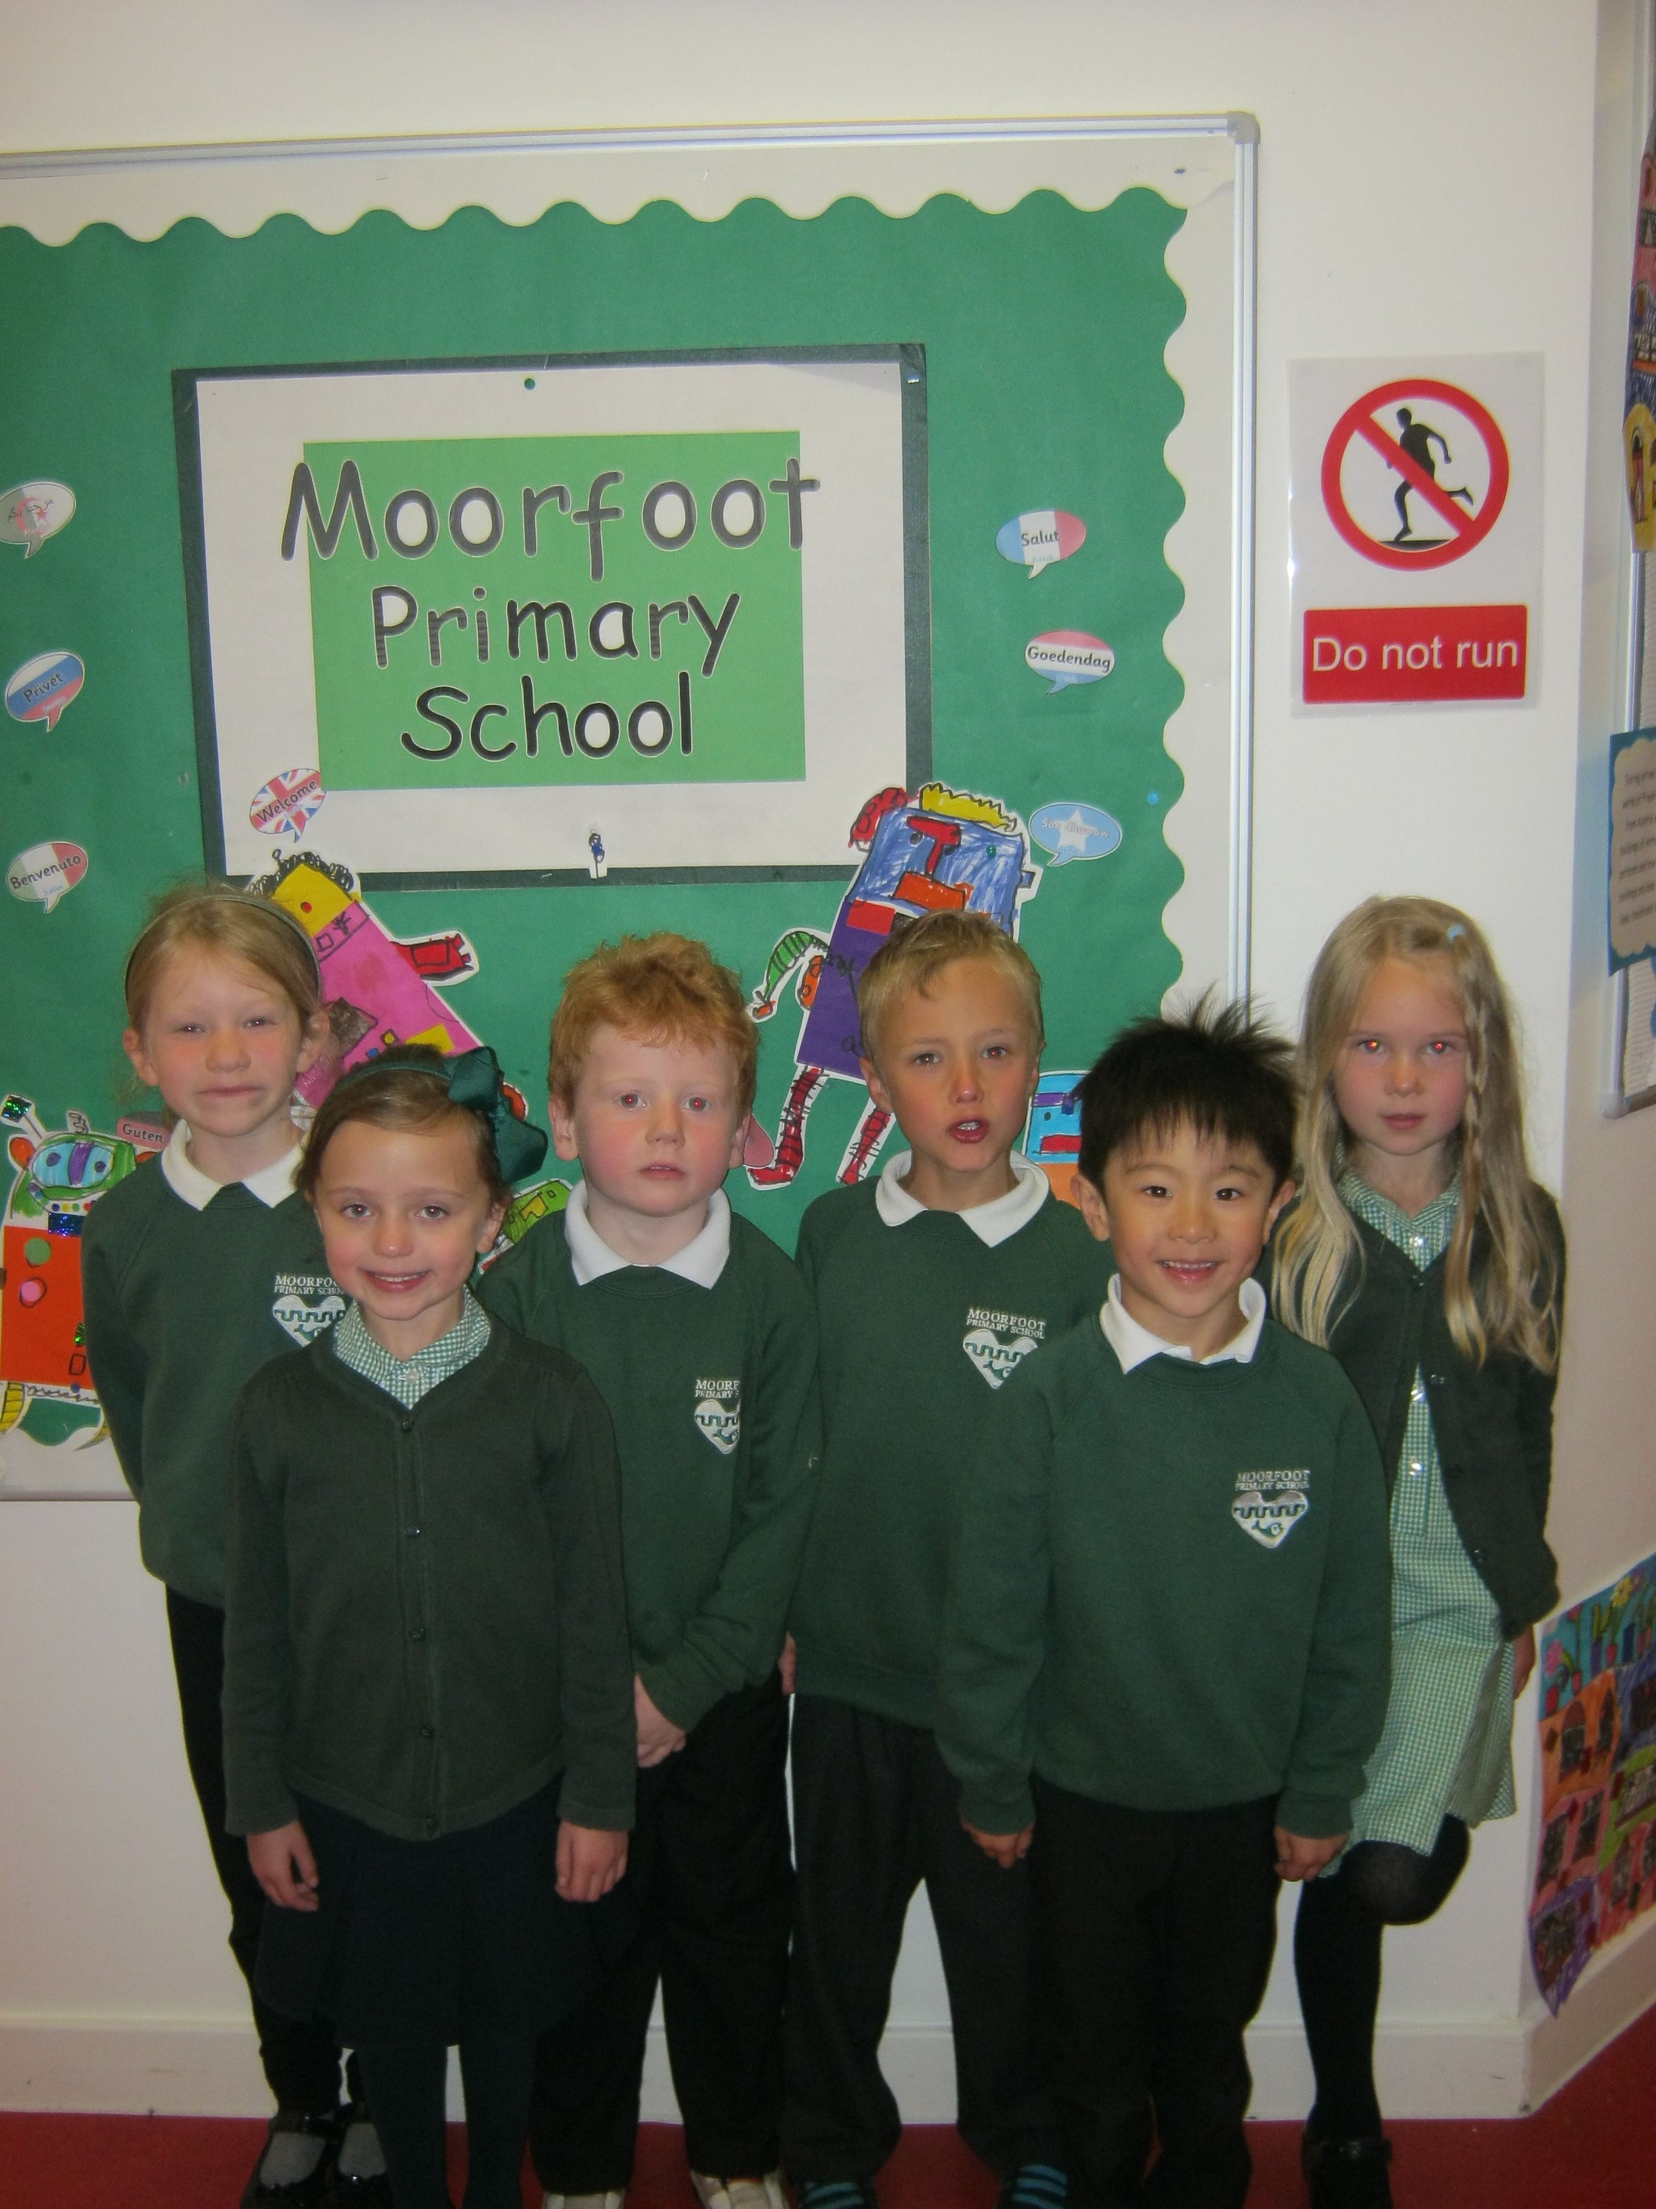

www.moorfoot.mgfl.net

Introduction

Dear Parent/Carer,

I am delighted to provide you with the Standards and Quality Report for Moorfoot Primary School for the session 2014–2015. This report highlights the progress we are making in key areas of our work.

Moorfoot Primary School’s vision statement is ‘Getting it Right for Everyone’. Our clear focus is to do the best for every child in our care, and in order to achieve this we also want to get things right for parents, staff, and the wider school community. Working in partnership with parents/carers and others, we strive to encourage our pupils to be successful, confident, and responsible; and to contribute to the life of our school and our community.

In evaluating key areas, evidence has been gathered from a wide range of sources, including:
● pupil performance in school, authority and national testing,
● school self-evaluation which includes classroom visits, jotter monitoring and professional discussions
● feedback from questionnaires from and discussions with pupils, staff, parents/carers and visitors
● evidence of pupil participation and success in a wide range of activities.

It is hoped that you will enjoy sharing our reflection upon our work of last session. Thank you for your on-going commitment and support to the work and life of our school.

Yours sincerely,

Mrs Jane E Lambley

Head Teacher

Progress in meeting the targets we set for improvement for 2014 – 2015
Priority | Progress in meeting targets
Improve how well children learn and achieve in:  - Number: improve staff awareness of number progression, and teaching of number  - Writing: embed and extend existing good practice  - RME: review and improve our curriculum  (French – added in due to opportunities available) | - Very good  - Some progress  - Some progress  - Very good
Improve the support we provide to help children develop and learn:  - SfL: embed and extend existing VG practice  - Confident Staff/Confident Children training  - Rights Respecting school  - HWB: implement Responsibility of All | - Good progress  - Good progress  - N/A  - N/A
Improve the quality of our work:  - Data analysis  - Develop staff as professional learners  - Implement authority Quality Improvements | - Good progress  - Very good progress  - Good progress

How well do children learn and achieve?
- Learning
Children at nursery and across the primary classes enjoy being at Moorfoot and are happy in their learning. Classroom observations, and feedback from children, parents and visitors confirm that pupils are highly motivated and that they enjoy coming to school. Parents and visitors report that they find the school welcoming, and responsive to any concerns, and all parents say they feel their child is safe and well cared for in school.
Children in the nursery show a high level of engagement and motivation. The nursery offers children the opportunity to be independent and to be involved in decisions about their play/learning and learning within the nursery is active and encourages children to make connections between learning. Nursery children have been given the opportunity to be more involved in making choices and inputting into nursery planning of topics they may like and what they would like to learn about through the use of discussion and responsive planning. Children are offered a wide choice of activities which are appropriate to their level and offer very good pace and challenge. Evidence of this can be seen through the positive feedback from primary 1 regarding the children’s numeracy and phonological awareness as well as how well children listen and follow instructions from an adult. In nursery and primary classes, children are involved actively in their learning. Head Teacher and peer visits to classes have found evidence of very good teaching and learning, with the majority of children being focused and engaged in all classes. They are encouraged, through their PLPs, to log their learning, and reflect upon it. With the support of their teachers they are encouraged to set themselves targets, to work towards meeting them, and then to check on progress and set new targets. Children are becoming increasingly confident in setting targets for literacy and numeracy but they require support in the area of Health and Wellbeing; this will be a priority for next session. In the primary school, children’s current targets are displayed on their desks to keep these at the front of their minds. We encourage children to consider their progress with targets when they complete their regular Learning Logs. Classroom observations show that teachers share the purpose of lessons with children, and help them to understand how they can succeed in their learning. Children are becoming increasingly skilled at self and peer assessment, which has included the use of stimulating resources such as i-pads as well as peer assessment sheets. Effective practice includes directing children’s attention to the success criteria and ensuring that comments are relevant to the learning objectives. Children have regular opportunities to work together in pairs and groups, as well as across classes, which helps them to support and learn from each other, to take on different roles and responsibilities, and also to develop team working skills. This has also been developed further in the Nursery with children learning how to self- and peer assess their learning at group time using a traffic light system and success criteria. The nursery children are also being given more opportunities to complete focused tasks working as a pair or in a small group. Teachers plan many very good interdisciplinary projects for children such as Democracy, World War One, The Titanic, Natural Disasters, Farming, Dinosaurs, Under the Sea, My Community and Scottish Topics; these motivate children and help them to make connections across their learning, as well as providing them with very good opportunities to develop skills for life and work. Class 4 organised a whole school election campaign following on from the general election, and took part in the UK wide BBC music project – Ten Easy Pieces. Feedback from children and parents indicate that these projects, and the end-of-topic celebrations of learning (such as the poppy enterprise, Cajon drumming performance and community enterprise), are greatly enjoyed, and motivate children to work hard and to high standards. Learning Walls chart the opportunities children are given to make decisions about what and how they want to learn. Through support kindly provided by the PTG we strive to bring learning to life through curriculum-linked visits such as Blair Drummond Safari Park, Torness Power Station, the National Museum of Scotland and Dynamic Earth; we also extend children’s learning horizons through inviting visitors in, such as visiting geologists, farmers, Warburtons, French specialist teacher, Hopscotch theatre group, volunteer community gardeners, as well as many other arts and sporting specialists. Our stock of i-pads has been extended through another successful bid for funding and these continue to be used to support peer-assessment and learning across the curriculum (e.g. recording and assessing personal presentations, film-making and editing skills, accessing numeracy resources).
- Attainment
All children are tested in language and maths at the start and end of P1 using PIPs. The results showed that Moorfoot children began the year above the national and Midlothian average in Maths, and this differential had been maintained at the end of the session. In Reading, Moorfoot children started the year slightly above the national but marginally below the local average; by the end of the session our P1s were above the local average and the gap between Moorfoot and the national average had been further widened. The vast majority of children had progressed in line with expectations, with a few individuals attaining beyond expectations. The PIPs test results are analysed and discussed with parents when appropriate, and support or extension programmes are implemented as necessary with the progress of identified individuals being monitored closely.
In line with all schools in Midlothian (and many others throughout Scotland) children in Primary 4, Primary 5 and Primary 7 sit standardised GL Maths and Reading assessments. In Reading, the majority of children in P7 scored above the national average, with a few significantly above. Scores in Maths were lower, which may be accounted for by the fact that the GL tests don’t align with the focus on numeracy which we are now following. This also has an impact when we compare data from the group’s PIPs scores in P1 and GL results in P4 – again overall we see expected gains in Reading whereas Maths results for the group demonstrated significant gains by P4 with a drop at P7. The P7 cohort were an unusual year group as of the 12 pupils who joined us in P1, 5 left over the years and an additional 4 pupils joined, resulting in a group of 2 girls and 9 boys by the P7 year, with significant differences in the attainment of some of the leavers and joiners. The GL results for our P5s and P4s paint a similar picture – both year groups scored very well in Reading, with the majority of children above average and a few well above. In P4 almost half the children have a reading age of 11+. Maths scores for these year groups indicated drops from previous measures, which again is likely to link to the change in focus to ensuring that children are very secure in number processes before moving on. In addition to the GL tests all teachers now administer Numeracy tests in both September and June which are used formatively to identify children’s next steps, and we will monitor these closely throughout this session to ensure that children are making the expected progress through the maths and numeracy curriculum .
Curriculum for Excellence levels (which are given by teachers for all children in the school), demonstrate that most children are making good progress from their own prior levels.
Teachers’ use of motivating contexts for writing (e.g. Titanic and World War One diary writing, dinosaur report writing and letters to Fantastic Mr Fox) has resulted in high quality content of children’s writing. We have done some work around presentation and promoting technical skills however we are aware we need to continue addressing these areas including spelling. Children are generally doing well in the tests of learned spelling and some are transferring this to their writing, however this is not yet consistent throughout the school. We are revising our marking policy to ensure that there are shared expectations as children move through the school. Children receive 2 hours of PE a week, and staff skills in delivering PE have been improved through working with the seconded PE specialist. Children continued to benefit from skiing for p4-7 and swimming for p4 and 5. Class teaching is planned around the Health and Wellbeing outcomes, and our 2 year programme ensures that children have important learning experiences around topics such as road safety (including kerbcraft), food standards, drugs education, and sexual health. Younger children’s awareness of road safety was enhanced by a Magic Show, and all children have become more aware of rail safety through workshops and participating in awareness raising competitions. Our healthy Tuck Shop is very well supported, and during health week awareness of healthy eating was raised through work around healthy snacks. Our health week included a range of activities (many of which were pupil-led) to promote health awareness and healthy lifestyles and provided opportunities for children to apply their learning from other curricular areas (e.g. numeracy).

- Achievement
Our vision statement at Moorfoot is ‘Getting it Right for Everyone’, and a key part of ensuring that this happens is by providing a broad curriculum which offers something for all children, and provides opportunities for them all to achieve.
Within nursery, children’s learning folios offer clear examples of how children have had opportunities for personal achievement and are a record of the children’s progress and achievements while in nursery. This year we have introduced floor books to help children reflect on their learning and recognise their achievements. Children have also had the opportunity to contribute to the Achievement tree, celebrating their successes outside of Nursery. The Nursery is consolidating the use of the Laevers Scale to assess indicators of Well-being and Involvement. Information gathered by the nursery teacher e.g. early-level steps and baseline assessments, are transferred to the P1 teacher, who then uses the information to inform her planning. Evidence of children’s literacy and numeracy skills are reflected in very positive PIP scores at the beginning of term. Within the primary, children are encouraged to recognise and record their achievements both within and outside of school in their PLPs; this has been further encouraged through the Moorfoot Medal initiative. This runs from Nursery through to Primary 7, and children are encouraged to develop within the three areas of Sport, Skills and Service. Their successes are recognised through the awarding of bronze, silver and gold medals, and shared and celebrated at assemblies. The children who participate do so enthusiastically, and all children are given regular opportunities to share their achievements both in class and at special achievement assemblies. One child in P3 was a runner-up in the national ReadingZone Picture Book competition.

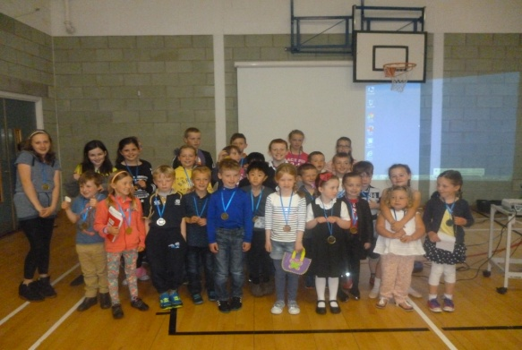

Moorfoot Medal Assembly

Around £500 was raised by the school for Scottish Love in Action, as well as £250 on Red Nose Day. Further funds were also raised by staff for Chest, Heart and Stroke. Class 4 raised £182 with their Poppy Appeal enterprise and Class 3 initiated a fundraising sponsored skip, raising an impressive £824 for the Nepal Earthquake Appeal which was linked to their class topic of natural disasters. The Eco-Committee have led very successful initiatives to reduce waste in the dining hall and classrooms and to increase recycling.

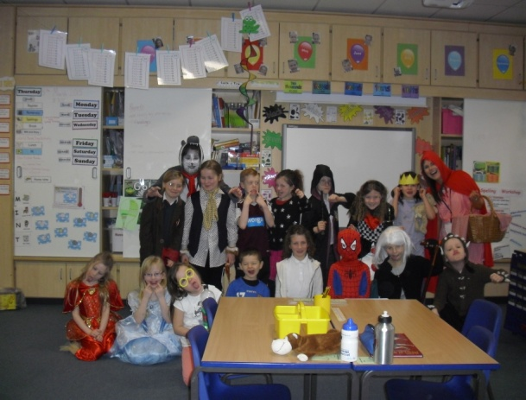
World Book Day 2015
- How well do we support children to learn?
Through planned improvements within our annual School Improvement Plan, we are continuing to develop our curriculum to ensure that it is broad and joined-up, and that it enables children to build upon previous learning from nursery to P7. Our ‘Star Planners’ ensure that children receive a very good range of experiences and outcomes as outlined in A Curriculum for Excellence. Our work with high school colleagues increasingly ensures that this coherence extends into the early stages of children’s secondary education.
Within the nursery, staff are involved in an ongoing responsive planning process that follows children’s learning and outlines areas for additional support where needed. Children’s next steps in learning are recorded in the folios and in weekly responsive planning. Very good learning activities are then planned to match children’s needs and are differentiated appropriately. Children’s emotional and social development is supported through everyday use of classroom rules and rewards policy as well as weekly circle-time sessions. Children are prepared for changes through an in depth transition policy designed through close working with the school.
Staff have continued to develop their skills and confidence in our previous priority of improving science teaching, particularly in the use of the unpicked outcomes, and the Science Fair was again a great success.
Outdoor Learning and challenge has again had a high profile with older children walking in the Pentlands and younger children completing differentiated walks in Arniston. P7s benefitted from the cluster camps, and P4-6 had a 3 day water and land sport experience at Port Edgar. Classes 2, 3 and 4 also developed their orienteering skills through input provided by the Midlothian outdoor education department. Children from Primary 6 and 7 had the opportunity to take part in cycle challenges including a 20k cycle from Temple to Musselburgh.
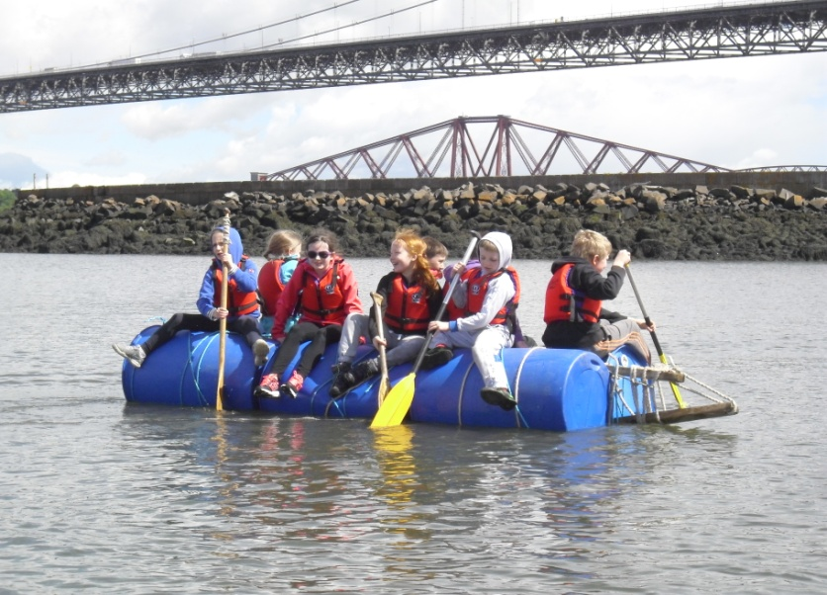
Port Edgar Watersports
Our ASG focus on numeracy has been very successful and has been taken forward through up-skilling teachers and learning-assistants in the delivery of number concepts. Staff have undertaken CPD to develop their knowledge and understanding of the significant early arithmetical learning as well as effective teaching methodology and are applying this learning in the classroom. The local authority has been impressed by the work that has been done within the ASG around numeracy and the commitment shown by staff.
Based on the previous priority of helping parents to understand our maths curriculum and how they can best support their children, we have continued to invite parents in to observe maths teaching, continued to set weekly maths homework, have run workshops for parents, and have made increased use of online resources to support learning at home (e.g. SumDog). Evaluations demonstrated that parents are appreciative of this initiative, and the PTG have suggested ways of ensuring greater take-up of our annual Maths open mornings. Pupil focus group feedback showed that our efforts to engage children in numeracy through active resources and diagnostic tools are resulting in children who enjoy number and feel positive about their progress.
Partnership working has once again been a strength in Moorfoot, and feedback from parents in November demonstrates that PLPs are effective in forming a link between home and school. We are fortunate in having many parents who volunteer in school, and our Parent Teacher Group has been very successful again in organising social events which strengthen the links between families and the school, and fundraising which has enabled our children to benefit from a wide range of trips and visitors. The PTG also provides valuable support with shaping our policies and improvements. Parental support of the Scholastic Bookfair resulted in £600 of books being purchased, with the ensuing commission used to purchase more books for the school. Nearly £500 was paid into school funds due to the support of our Rag Bag initiative, which was then used to subsidise trips and events. A member of our admin staff made a successful bid to REPIC which resulted in the school receiving an additional 4 i-pads. Our very good partnership working also extends to working with a range of individuals and organisations outside of school (including Active Schools, whose clubs are well supported), who can enrich our pupils’ experiences. The pupil council led a focus on social skills and cross school home teams have been formed. We will develop this next year. Older children have shown initiative and enterprise by setting up a library club, and are currently working with parents and local librarians to make improvements. Feedback gathered from leaders of clubs, and visiting specialists, around areas of motivation, behaviour and attainment has been very positive, as has been the support and welcome that visitors report that they experience within the school. We encourage leaders to feedback any particular strengths or concerns they have about individuals so that the school can act upon these.
The local authority has recognised the skills of our learning assistants in numeracy and how well they work with class teachers, and they have went on to lead CPD for other schools in the cluster. Our Support for Learning teacher works with the HT to analyse the results of PIPs, reading, spelling and maths diagnostic tests, and works with teachers and Learning Assistants to devise programmes to support and extend children’s learning, including our most able children. Regular planned liaison between the adults working with children, including parents, ensures that programmes of work are dynamic and responsive, and children are encouraged to reflect upon and contribute to their targets. We also work hard to ensure that children have many opportunities to support and learn from their peers and younger children: these include buddies, playground pals, home teams, as well as regular mixed stage and whole school topics. We have continued with the whole-school approach to positive behaviour (Good to be Green) which continues to motivate children throughout the school. Parents provided very positive feedback on this in their November questionnaires. There is a termly whole-school behaviour review. Targeted support for individuals and classes is provided where necessary, sometimes with input from specialist colleagues. Our transition arrangements from nursery to P1 and P7 to S1, as well as between classes within the school, are well established and regularly revisited, and help to provide a very good smooth transition for children, socially as well as academically. All P7 pupils completed a Profile at the end of the session, outlining their achievements and their perceptions of themselves as a learner. High school staff report that these have been very well received in secondary.

- How well do we improve the quality of our work?
The school has a well-established vision and set of values, and these are used to shape the direction in which the school develops. In order to ensure that we continue to improve, very good self-evaluation at all levels is built into the school’s annual calendar, and the results help to direct our School Improvement Plan. Our SIP is regularly reviewed, and guides our actions while still providing flexibility for opportunities which can emerge during the course of the year, eg Modern Language and the national 1+2 initiative was not an identified priority this session but we chose to take up the opportunity for regular specialist input in French. Children and parents fed back very positively on this initiative. Staff are involved in whole school improvement planning, as are parents through the PTG and individuals working with staff members. Children are consulted through focus groups and through our various Pupil Groups. We strive to have a coherent approach which links to CPD. Staff engage in professional dialogue with colleagues and undertake CPD activities, which they then share with colleagues. This year there have again been opportunities for staff peer observation (both within Moorfoot and the wider cluster) and close working with ASG colleagues in the cluster working priority of numeracy, which staff report as having been highly beneficial. CPD activities have an impact on the service through positive changes reflected in the yearly/term plans. New council initiatives are undertaken in a timely manner e.g. HT and staff undertaking CPD in visible learning and practitioner enquiry, and SEAL training. Early Level Steps are being used in learning folios in nursery, and all our teaching staff are trained in Cooperative Learning or Critical Skills. The School Group Manager considers and endorses the evidence upon which the school’s self-evaluation is based. Feedback from authority visits is consistently very positive. The headteacher has a regular programme of meetings with staff to discuss and set action points around forward plans, assessment results, and pupil attainment, as well as annual appraisals and planning of CPD. She also visits classrooms regularly, both formally and informally, and meets with pupil focus groups twice a year. Results from focus groups are fed back to staff and any actions planned to ensure improvements. The headteacher liaises regularly with the Support for Learning team, to ensure that children’s changing needs continue to be met, and that resources are used effectively. The Support for Learning teacher regularly meets with learning assistants to plan and review progress, as well as team teaching and modelling of good practice, which staff report as being very useful.
We actively invite feedback from the school community, and act upon it. In the nursery, there are secure processes for gathering feedback from parents, both formally and informally, and there is evidence of feedback being taken into consideration in the Nursery Improvement Plan. Parental feedback (from our nursery self-evaluation meetings, parents’ evenings, questionnaires, comments box, pupil reports, and through the PTG as well as informally) is shared with staff, and any individual concerns are picked up, as is feedback from visitors to the school. Similarly, pupil questionnaires are scrutinised, and teachers speak with children about any issues raised. Pupil questionnaires are passed on to new teachers, along with any relevant comments from Pupil Report feedback, to ensure that new staff are aware of any concerns. Staff feedback is regularly sought and acted upon. We have reviewed assemblies to provide regular opportunities for the sharing of achievements and the work of our various pupil committees, and children’s response to these changes has been very positive. Results over time demonstrate improvements in prior areas of concern raised by staff, children, or parents. We review and update our policies in partnership with the authority. There is very good distributed leadership at all levels throughout the school, including pupils, teachers, non-teaching staff, and parents. Opportunities to develop teacher leadership are actively sought eg HT and CT Numeracy Coordinator attending and implementing recommendations from an inter-authority Numeracy conference. Staff professional learning is shared and actions are set to ensure an impact on learning and teaching. Opportunities for adults and children to extend their own enthusiasms, and to cascade to others, are well supported.

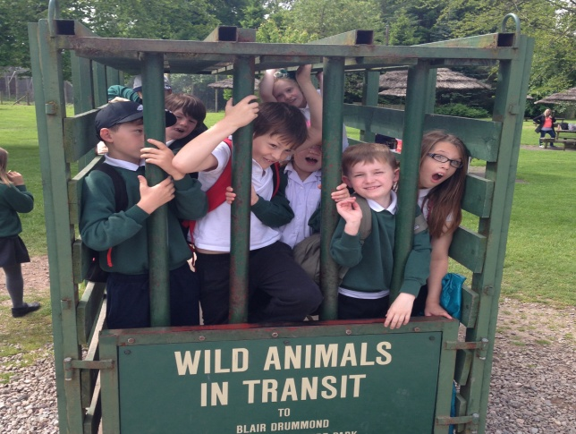

Summer Outing to Blair Drummond Safari Park

