Starting School
At
Moorfoot Primary
2021-2022

A friendly, kind and caring place to be!

LIFE
Learning Inspiration
Friendship Enjoyment
General Information

Moorfoot Primary School has 4 primary classes and is situated in the village of North Middleton.
Address
Moorfoot Primary School
41 Borthwick Castle Road
North Middleton
Gorebridge
Midlothian
EH23 4QS

Telephone: 0131 271 4640 (School Office)

E-mail: moorfoot_ps@midlothian.gov.uk
Web: www.moorfoot.mgfl.net

Staff

Head Teacher John Dagger

Class Teachers Hazel Taylor

Rosie Holligan

Lisa Fallens and Hayley Nel

Jonathan Weedon and Sophie Stirling

Support for Learning Kim Asut

Learning Assistants Tracey Melvin
Gillian Mackie

School Office Staff Lynn Webb

Facilities Manager Davina Webb

Visiting Specialists P.E- Joanne Thom

Cook Michelle Jones
Kitchen Support Karen Ferguson
Welcome

We are looking forward to your child starting Primary 1 at Moorfoot Primary School. We hope this booklet will be helpful and ensures that your child has a happy start to school.

We wish to make the transition from nursery to primary school as smooth and enjoyable as possible for your child and yourself. We would like to have a strong partnership between home and school so if you have any worries or concerns please get in touch with us.

Starting school is a big step for children. There are many new experiences, new people to meet and new routines to adjust to. Every child will cope with these experiences in a different way but with patience and understanding we are certain that your child will soon feel safe and secure in their new environment.

First Day
Primary 1 will begin school in two groups. There is a letter within your pack telling you which group your child is in and what times they should attend school for their first 3 days.

Wednesday 18th August
Group 1- 9:30am- 11:00am Group 2- 1:30pm-3:00pm

Thursday19th August
Group 2- 9:30am- 11:00am Group 1- 1:30pm-3:00pm

Friday 20th August
Both groups- 8:50am-12:25pm
Important Information

Please note that due to Covid-19 these times and arrangements may very well change. We will contact families if anything changes.

Monday –Thursday 8:50am - 3:15pm
Friday 8:50am – 12:25pm

Please note that due to Covid 19 the 2020-2021 session we had a staggered start and finish time for the children. We are hoping this will not happen next session but if the guidance says we have to then we will make parents aware as soon as possible.

Transport
If your child is brought to school by school bus or taxi, then any change in normal arrangements must be told to the school and to the bus company by the parents – it is the parents’ responsibility to notify the bus company of any changes.

Homework Folders
The PTG kindly contribute towards the school providing children with a school homework folder which the children should bring to school each day. Any homework and notes for your attention will be sent home in this. Your child will receive this on their first day of school.

Clothing
Please make sure all items of clothing and footwear are clearly marked with your child’s name. Please try to teach your child to be independent before starting school e.g. doing up buttons, zips, opening and closing bags etc. This saves a huge amount of teaching time.

P.E.
Due to Covid 19 restrictions the children have been coming to school in their PE kit on PE days. This was so the children were not changing in school. We expect this to be the case again starting next session. More information will be given once your child begins school and we will make sure you are informed of the PE days.

Free Fruit
On a Wednesday the P1 and P2 children are offered fruit. If your child has any allergies to fruit then please let the class teacher and school office know.

Snack
Your child can bring a snack to eat at playtime. One item is enough. We recommend fruit or a healthy snack. We prefer no sweets to be eaten as a snack. We are also a nut free school as we have some pupils with a nut allergy.

Milk The children can have milk after break time in school if they wish to. A letter will follow about this during the first week of term to give you more information.

Playtime
The Primary 1 children will be introduced to Mrs Melvin and Gillian, who work in the playground, before they go outside to play. The P1 children are normally given a P7 buddy to support them in settling into school but due to covid 19 we are unable to do this at the moment. If the restrictions change around this then we will start the buddies again. Please do not send toys in to school for playtime.

School Meals
All Primary 1-4 children receive free school meals from August. Our school kitchen provides a range of hot and cold meal options Monday- Thursday and the children will be offered a packed lunch to take away on a Friday.
Menus are enclosed in this pack. It is great if you can talk to your child about the meals they like so they can think about what they will have at lunch time and also keep a note of what you have ordered. You may prefer to send a packed lunch in from home for your child. Due to Covid 19 during 2020-2021 the children ate their lunch in the classroom or in better weather outside. We will update parents if this is going to change for next session.
At lunch your child will be given support to cut up food and they will be reminded to use a fork or spoon and not their fingers. The children go outside to play after finishing their lunch.

Money
Midlothian Council’s preferred option for paying is by ParentPay, which is an on-line payment system that most of our parents use. You will be issued with information at the start of session to enable you to set up an account. If you choose to send money to school, it should be in a green envelope provided by the school office. Please note that we do not accept cheques in school.
Literacy
At Moorfoot we use a literacy programme called Read, Write Inc. to help the children learn to read, write and spell.
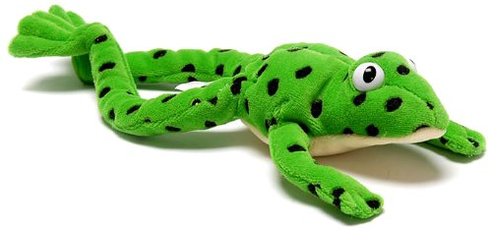
Fred the Frog puppet plays an important role in our lessons. Fred is only able to speak in sounds, not whole words. We call this Fred Talk.
For example, Fred would say m-a – t we would say mat. Fred talk helps children read unfamiliar words by pronouncing each sound in the word one at a time. Children can start blending sounds into words as soon as they know a small group of letters well. During lessons children are taught to hear sounds and blend them together in sequence to make a word. We start with blending oral sounds, then progress to reading the letters and blending them together to read the word. Children are taught how to form letters using a handwriting phrase to help.
Spelling with your Fred Fingers
Children are taught to use their fingers to help them write words. The children say the word out loud and break it down into its individual sounds. If a word has 3 sounds children hold up 3 fingers, 4 sounds 4 fingers etc. Children then pinch each finger as they say the sounds needed in the word then they write the letters that represent each sound.
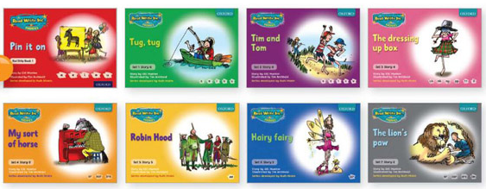
Storybooks
After learning the first set of sounds children begin to read storybooks that are closely matched to their developing phonic knowledge. The storybooks consist of green words linked to the sounds they have been learning, red word (words that are not decodable) and challenge words to extend children’s vocabulary. After children have practiced these words individually they are prepared to see them in context in the story. Activities such as comprehension questions, partner discussion and writing activities based on the book follow.

Numeracy
At Moorfoot in the Early Years we have a SEAL approach which stands for Stages of Early Arithmetical Learning. This approach allows the children to apply skills in different ways and contexts before moving on to the next stage.

The SEAL approach highlights the importance oral work over written work so that mental strategies are encouraged and developed before algorithm. It is important for the children to explore and learn a range of strategies and to be able to explain these. The children will have lots of experience in counting forwards and backwards right up to P7.

We use a range of resources and equipment to help support the teaching of numeracy within P1 but a recent purchase we made was the Numicon resource. This resource allows the children to see connections with numbers as they learn by seeing and feeling. Physical resources like the colourful Numicon Shapes are an important part of Numicon. The holes in the Numicon Shapes represent the numbers 1 to 10. When they are arranged in order, as in the picture below, children can easily see connections between numbers, such as ‘one more’ or ‘one less’.
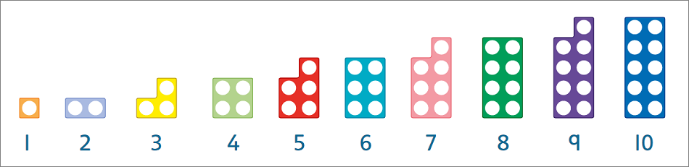

Later on, your child will be able to see more complex mathematical ideas, like how two fours make eight, three twos make six, and so on. This lays the foundation for their understanding of number all the way through school.

We also use ICT to help support numeracy teaching at Moorfoot. Education City is used in P1 as well as the Ipads to help consolidate knowledge and understanding.

Seesaw
If your child attended Moorfoot Nursery then you will have already been using Seesaw to keep up to date with what your child was doing in nursery. We use this in the Primary School too.

Seesaw is an online platform that enables the children to capture and share their learning with teachers and parents. In Primary 1 it will mainly be class teachers posting your child’s work or communicating with you through Seesaw.

Towards the end of P1 the children will be encouraged to make posts onto Seesaw themselves. The teacher has to check and approve all posts before they are added to the class learning journal. You will be given more information about this once your child has started at Moorfoot.

School Uniform for Next Session
Please note that as children go into P7, they receive the privilege of wearing the turquoise hoodies and therefore they are the only pupils able to wear these in school. Regarding the bookbags, children will receive one of these in their primary school time, but you are very welcome to order a replacement, at your own expense, if you wish to do so. New P1 children will not require to order a bookbag as they will receive their complementary one, funded by the school and PTG, when they come into school.
https://www.border-embroideries.co.uk/schools/moorfoot-primary-school.html
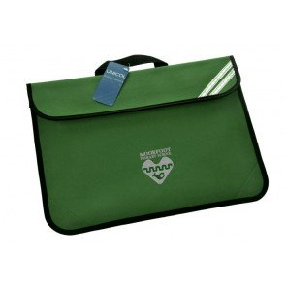
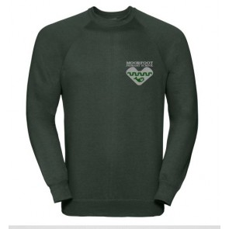

We hope you find this new online ordering service manageble to use. If your have any queries, please do not hesitate to email us at moorfoot_ps@midlothian.gov.uk and we will do our best to assist you where we can.
We would like to remind you that, as much as we would encourage children to wear the school uniform with the school logo, wearing school coloured plain sweatshirts is also acceptable,

First Day Checklist

- A schoolbag
- A snack for break time
- A water bottle
- All belongings clearly marked with your child’s name (Please label everything)
- Arrangements for home time are understood by your child and the school are aware
- Ensure you have told the school about any appropriate medical instructions
- Do the office have an up to date emergency contact number?

We hope that you have found this booklet helpful and that it has answered any questions you had about your child starting school.

